Get Up and Move! (GUM!) Capstone Idea & the Dangers of Sitting in the Modern Workplace
By Mark C. Angel

Problem or Need: Desk workers spend too much time sitting behind their desks (Biswas A, et. al.). In order to minimize that danger, it is necessary to move intentionally and more often throughout the day. “Physical activity is anything that gets your body moving. According to the 2018 Physical Activity Guidelines for Americans, 2nd edition, adults need to do two types of physical activity each week to improve their health–aerobic activity and muscle strengthening. (www.cdc.gov)”
Target User: People who spend more than four hours a day doing desk or computer works (Buckley JP, Hedge A, Yates T, et al)
Solution: Get Up and Move! (GUM!) techniques/solutions for desk workers:
- Many jobs require people to spend unhealthy amounts of time sitting at a desk. GUM! will:
  - Educate desk workers about the consequences of sitting at the desks too much, and
  - Encourage and motivate desk workers to get up and move on a regular basis.
- People who spend long periods of time (more than half an hour at a time) staring at a screen need to be informed about the dangers of eye fatigue (hopkinsmedicine.org). GUM! will teach the 20-20-20 rule:
  - The American Academy of Ophthalmology recommends the 20-20-20 rule: Every 20 minutes, shift the eyes to look at an object at least 20 feet away, for at least 20 seconds.
- GUM! will teach desk workers about the benefits of standing at their desk (Creasy SA, et. al.), and how employers might enable them to do so:
  - Stand at desk as much as possible: phone calls, reading, watching media, et c.
  - Prepare work space to be conducive to standing (i.e. Figure 1).
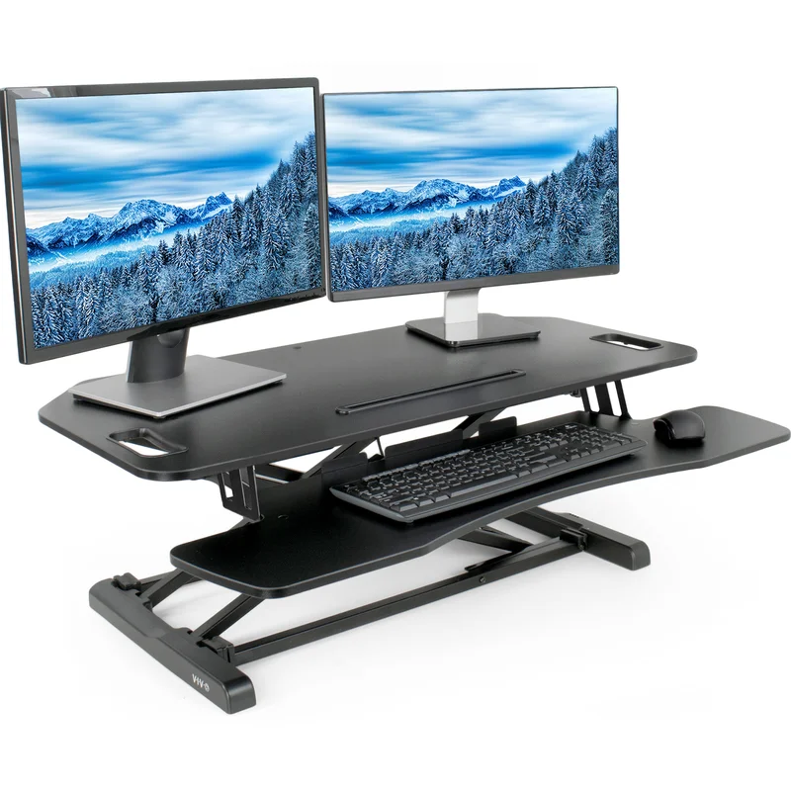
Figure 1 (standing desk accessory: monitors not included)

- GUM! will teach exercises that can help reduce the dangerous effects of desk work:
  - BEST Practices: Bouncing, Elevating, Shaking and Twisting
  - JaMMing: Joint and Muscle Mobilization
  - Quantum Foam meditation
  - Golden Ball energy cultivation
  - For even greater health benefits, walk more (Smith-McLallen, et al.).
Summary: GUM! is a set of exercises that promote mobility, circulation, strength and balance. Regular exercises scattered throughout the day is more effective then clumping it together, for example, going to the gym. “Prolonged sitting is a risk factor for all-cause mortality, independent of physical activity. Public health programs should focus on reducing sitting time in addition to increasing physical activity levels” (van der Ploeg HP, et al.).
GUM! techniques can be done in sequence or spread throughout the day. The GUM! program is 30 minutes long and broken into six chunks. GUM! focuses primarily on the psychomotor aspect of the program. If applied to a typical 8-hour work day, learners can fit the exercises into six, 5-minute sessions, spread equitably throughout the day (i.e., for an 8-5 job: 9am, 10am, 11am, 2pm, 3pm, 4pm). Over the course of a week, this would provide the CDC’s minimum recommended daily exercises time (CDC).
How to determine if someone can benefit from GUM!
1. Do they sit or recline more than four hours during a work-day (e.g., 8a-5p)?
2. Do they sit for more than one hour at a time without getting up and moving around a little during a work-day (e.g., 8a-5p)?
3. Do their work primarily entail sedentary behavior (sitting, driving, watching a screen, et c.)?
References:
Sedentary time and its association with risk for disease incidence, mortality, and hospitalization in adults: a systematic review and meta-analysis.
Biswas A, Oh PI, Faulkner GE, Bajaj RR, Silver MA, Mitchell MS, Alter DA. Ann Intern Med. 2015 Jan 20;162(2):123-32. doi: 10.7326/M14-1651. PMID: 25599350

Buckley JP, Hedge A, Yates T, et al
The sedentary office: an expert statement on the growing case for change towards better health and productivity, British Journal of Sports Medicine 2015;49:1357-1362.

https://www.cdc.gov/physicalactivity/basics/adults/index.htm?CDC_AA_refVal=https%3A%2F%2Fwww.cdc.gov%2Fphysicalactivity%2Feveryone%2Fguidelines%2Fadults.html

https://www.hopkinsmedicine.org/news/articles/protect-your-eyes-from-screen-time
Creasy SA, Rogers RJ, Byard TD, Kowalsky RJ, Jakicic JM. Energy Expenditure During Acute Periods of Sitting, Standing, and Walking. J Phys Act Health. 2016 Jun;13(6):573-8. doi: 10.1123/jpah.2015-0419. Epub 2015 Dec 21. PMID: 26693809.

Smith-McLallen, Aaron & Heller, Debbie & Vernisi, Kristin & Gulick, Diana & Cruz, Samantha & Snyder, Richard. (2016). Comparative Effectiveness of Two Walking Interventions on Participation, Step Counts, and Health. American Journal of Health Promotion. 31. 10.1177/0890117116658012.

van der Ploeg HP, Chey T, Korda RJ, Banks E, Bauman A. Sitting time and all-cause mortality risk in 222 497 Australian adults. Arch Intern Med. 2012 Mar 26;172(6):494-500. doi: 10.1001/archinternmed.2011.2174. PMID: 22450936.

